**XML Lab1**

1. **Write Xml file named family with the following structure**

**Don’t Use Mixed Content Element.**

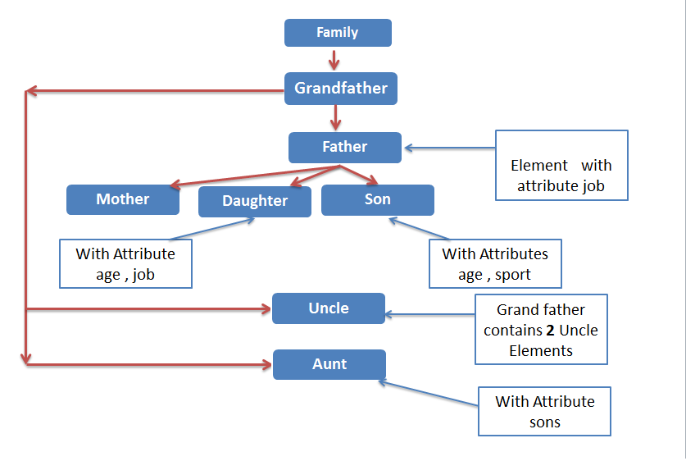

**For the previous Xml file write the DTD file with the following rules**

1. Job attribute with father and daughter Elements has a value from (Engineer, Accountant, Doctor) and set the **default** value for it with **Engineer**
2. Age attribute with Daughter and son Elements is Required and has NMTOKEN value
3. Sport attribute with son Element has a value from( tennis , football )

Default value football.

1. Sons attribute with Aunt Element is Optional

-------------------------------------------------------------------------------------

1. Write DTD file for POrder.xml file.

-------------------------------------------------------------------------------------